Naval Research Laboratory Optical Layers Project - 2016 Gulf of Mexico Cruise Plan

Objectives
The main objective for this deployment is to test newly-developed methods to remotely detect and characterize optical layers using ship-borne polarimetric and multi-wavelength lidars and the Calipso spaceborne lidar. These measurements will be complemented with in-situ time-series and underway measurements of temperature, salinity, and current profiles, detailed in-situ profiles of bio-optical properties, laboratory water sample analyses, and passive image retrieval of biogeochemical properties from both airborne and satellite sensors.
Our secondary objectives are to 1) assimilate the underway measurements of the physical and bio-optical properties into ocean circulation models to nowcast and forecast the 3-D optical fields in the study area, and 2) to quantify the role of Langmuir circulation and sub-mesoscale features (eddies, fronts, filaments) in the formation, evolution, and transport of particles in coastal zones.

Dates
March 16-27, 2016

Vessel
R/V Pelican. The R/V Pelican is a 116 ft., coastal research vessel intended for use on the continental shelf in the Gulf of Mexico, Caribbean, and Western Atlantic.

Location
The study area of the cruise is the Northern Gulf of Mexico, near the Mississippi River Delta and the coasts of Louisiana, Mississippi, and Alabama. The cruise will embark from Cocodrie, Louisiana, the homeport of the Pelican, and disembark at Gulfport, Mississippi. We are focusing mostly in the area just east of the Mississippi delta, but will also measure near the Mississippi River plume and the Barrier Islands between Mobile Bay, Alabama and Gulfport, Mississippi (figure 1).
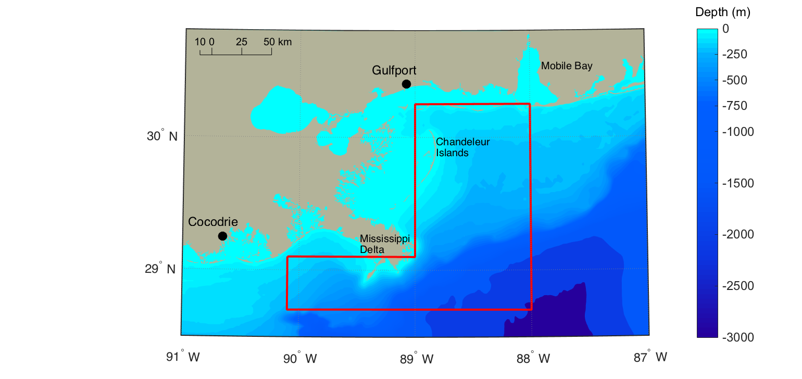
Figure 1. Map of the general area of the experiment

Naval Research Laboratory and Other Participants

NRL
Dr. Deric Gray, Remote Sensing Division, Code 7231
Glen Frick, Remote Sensing Division, Code 7227
Dr. Derek Burrage, Oceanography Division Code 7332
Dr. Joel Wesson, Oceanography Division Code 7332
Andy Quaid, Oceanography Division, Code 7332
Ian Martens, Oceanography Division, Code 7332
Wes Goode, Oceanography Division, Code 7333

Others
Dr. Fraser Dalgleish, Harbor Branch Oceanographic Institute, Florida Atlantic University
Dr. Anni Dalgleish, Harbor Branch Oceanographic Institute, Florida Atlantic University
Nicole Stockley, Harbor Branch Oceanographic Institute, Florida Atlantic University
Dr. Robert Stavn, University of North Carolina, Greensboro
Amy Gonsalves, University of North Carolina, Greensboro

Science Goals
There is no remote sensing technique that adequately measures vertical structure in the ocean – passive systems provide synoptic, spectral information about the ocean surface, while active systems can detect, though not necessarily identify, subsurface layers on limited spatial scales. The gaps between these two are beginning to be filled by hydrodynamic models, which are incorporating particles and their optical properties to predict vertical structure and dynamic evolution. But they still require data either from passive systems, along with many simplifying assumptions, or directly measured values from surface or subsurface-based platforms. And yet despite the difficulties in determining the subsurface structure of the oceans, it is difficult to overstate its importance to naval operations. Nepheloid layers are notorious for hindering Mine countermeasure (MCM) operations, and yet are exceedingly difficult to detect remotely. Particle layers are critical in determining diver visibility/vulnerability, yet are routinely ignored in products from passive sensors. Dinoflagellates, which are responsible for much of the bioluminescence in the ocean, exhibit diurnal vertical migration behavior, and along with other phytoplankton serve as food sources for larger zooplankton, which are acoustical scatterers.
The major science goal of this deployment is to evaluate newly developed methods using ship-borne polarized and multi-wavelength lidars to not only detect but also characterize environmental features of layers such as location in water column and magnitude, size, shape, and composition of the particles. Polarized lidar signals have shown potential in determining particle aspect ratios; using both linear and circular polarization signals may also provide a way to determine orientation. A profiling polarimetric lidar that can view particle layers at multiple angles can also help determine whether the angle show preferred orientation. The combination of multiple view angles and polarized returns can help determine if particle layers have preferred orientations under different flow conditions. Using polarimetric lidars both above and below the ocean surface can also lead to better understanding of the effect of the sea surface on the polarized signal, and observing particle layers from several distances can help to determine the effects of multiple scattering on the polarimetric signatures. A lidar using multiple laser wavelengths has also shown the ability to discriminate between biological and mineral particles. Using straightforward bio-optical models may also allow one to separate the signals in constituents such as chlorophyll, mineral, and chromophoric dissolved organic matter (CDOM) as a function of depth. Testing these hypotheses is the primary science goal of the cruise.
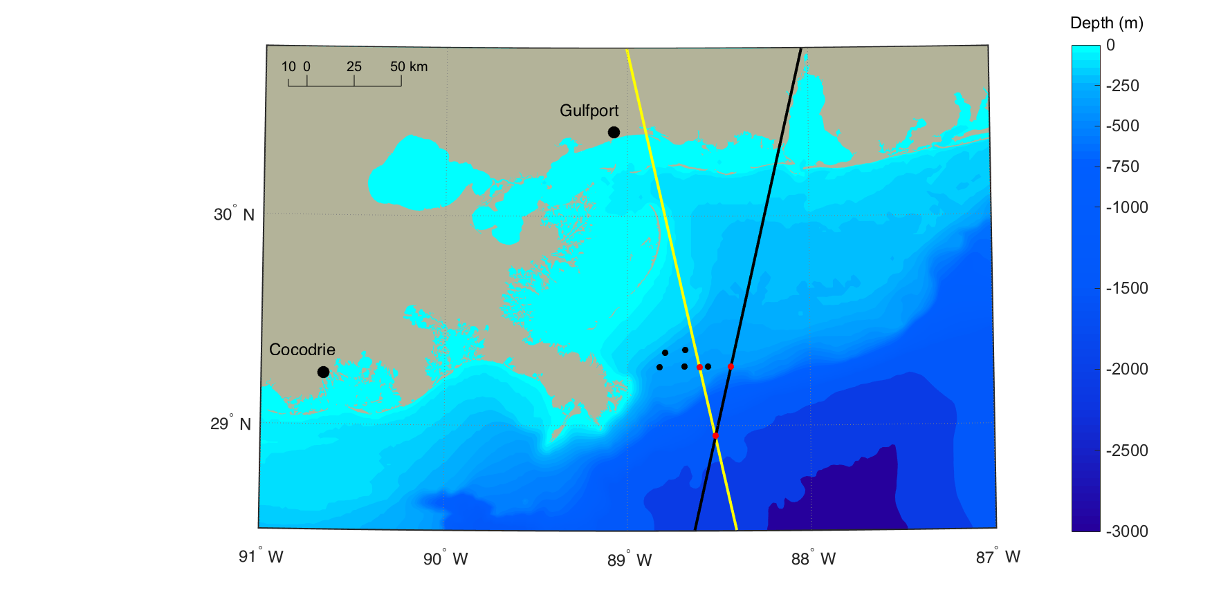
In addition to the ship-based lidars, NASA’s Calipso lidar has shown an ability to detect subsurface layers in the ocean. However, the scope and validity of the layer retrieval has only begun to be examined. Some of our preliminary work at NRL has indicated that the layer retrieval can be improved by increasing the signal-to-noise ratio in the data. We specifically looked at signal-to-noise ratios for 1) daytime and nighttime data, and 2) averaging multiple Calipso profiles over longer spatial tracks. One of our science goals is to test both of these during the cruise. The location and timing of the experiment was chosen to coincide with two Calipso overpasses, daytime and nighttime (figure 2).
Figure 2. Map showing the tracks of the Calipso daytime (yellow) and nighttime (black) overpasses, along with the mooring locations. Black dots represent bottom mounted moorings already in place, and red dots the mooring to be deployed and retrieved during the cruise.
One secondary science goal is to assimilate the cruise data into coupled ocean circulation models to forecast optical layers on a 72 hour time scale. We will send in-situ optical data to NRL Stennis to use in conjunction with passive satellite measurements of ocean color. They will ingest the data into the forecast model and provide prediction for the next two days, which can then be tested with the data collected over the next two days. One of our long-term goals is to modify the model to start ingesting lidar data in addition to in-situ optical profiles.
The other secondary science goal is the investigation of Langmuir circulation with a series of dye releases. Recent studies at NRL have shown Langmuir circulation may be more complicated than previously realized. Our goal is to investigate this mixing by releasing different colored dyes at different depths in the water column. Aircraft overflights with hyperspectral pushbroom sensors and area cameras fitted with fluorescence filters will measure the surface evolution of the dyes. The multi-wavelength lidar will also be equipped with fluorescence filters and will measure the subsurface evolution of the dyes.

Data to be Collected
The data that will be collected include several sensor classes: passive airborne, ship-borne and in-situ lidar, in-situ bio-optical profiling, water samples, current profiles, and temperature, salinity and optical backscaterring time series from sensors on a wire mooring and water samples, and current profiles. The undulating Scanfish will be towed behind the vessel and collect continuous data of the depth, temperature, conductivity, absorption and attenuation coefficients at 83 wavelengths, backscattering, fluorescence of chlorophyll, CDOM, and phycoerythrin, and the vertical diffuse attenuation coefficient. The bio-optical profiler will provide high vertical resolution measurements of the absorption, scattering, attenuation, backscattering, fluorescence, volume scattering functions, particle size distributions, and currents. Individual water samples will be collected at discrete depths and analyzed for pigments (HPLC) and total suspended solids (TSS), and further partitioned into organic (POM) and inorganic (PIM) fractions. The combined towed undulating Scanfish, shipboard lidar, bio-optical profiler, wire mooring, and water samples will be used to characterize and inter-compare bulk optical properties. Scanfish data will be sent to NRL-Stennis to assimilate into optical forecast models.
Three lidars will collect profiles while the ship is underway and on station. The ship-borne polarimetric lidar (SLOP) measures vertical profiles of the polarized backscattering in the water column – both linear and circular. The ship-borne multi-wavelength lidar (MuWLE) collects profiles at several laser wavelengths between 410 – 710 nm, and profiles of chlorophyll fluorescence. The profiling lidar will be deployed in conjunction with the bio-optical profiler, and collect polarized lidar data at different depths and orientations.
Towards the beginning of the cruise we will place bottom-mounted moorings with acoustic doppler current profilers (ADCPs) and optic profilers along each Calipso track at the shallower depths, and a wire mooring with temperature, salinity, and pressure sensors and optical backscattering sensors at the crossing point (refer to figure 2). Currents, temperature, salinity, and backscattering profiles will be continuously measured at these fixed locations throughout the deployment. These measurements will also be combined with the lidar and bio-optical profiles and assimilated into the optical field forecast models.
The airborne measurements will provide surface measurements of biogeochemical and thermal properties, and are essential in identifying features such as eddies, fronts, and filaments in the coastal zone. Comparing the visible and thermal signatures of these features has proven useful in separating water masses. Particle layers can serve as a tracer for these features, and also created or destroyed by them. These features are nearly impossible to observe from the surface vessel, and in many cases occur on time scales that are too short to be effectively observed with satellites.
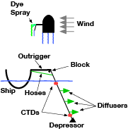
A series of dye releases from the ship will also occur periodically throughout the deployment. Up to four dyes will be released simultaneously at different depths – from the surface down to the mixed layer (if reachable). See figure 3 for details. Special care will be taken to keep the dyes out of the ship wake, and they will be monitored by the aircraft over a period of 3 hours to measure the vertical mixing rates under different atmospheric conditions. At the end of the dye release, the ship will travel through the dye plume and attempt to measure the vertical distributions of the dyes using the multi-wavelength lidar and fluorescent filters for each dye. High-frequency ADCPs on the ship will be used during the release and subsequent pass to measure the near-surface currents.
Figure 3. Illustration of the Dye release. The top figure (top-down view) shows the vessel traveling perpendicular to the wind direction with the outrigger extended. Dye will be sprayed onto the sea surface from the outrigger. The bottom picture illustrates the towed depressor and the dye released at different depths in the water column.
Finally, on the days of the Calipso overpasses the ship will collect underway optical data for several kilometers along the Calipso track, allowing us to test different averaging schemes for both daytime and nighttime data. We will do a bio-optical profile station around the time of the overpass.

Sampling Strategy and Stations
The main activity on this deployment is underway measurements with the two ship-board lidars and simultaneous measurements with the Scanfish, punctuated with periodic stations with the CTD/water samples, bio-optical profiler, and profiling lidar. The Hyperpro will also be deployed to measure the downwelling irradiance/upwelling radiance and diffuse attenuation profiles, and the remote sensing reflectance will be measured with an ASD. A map of station locations is shown in figure 4.

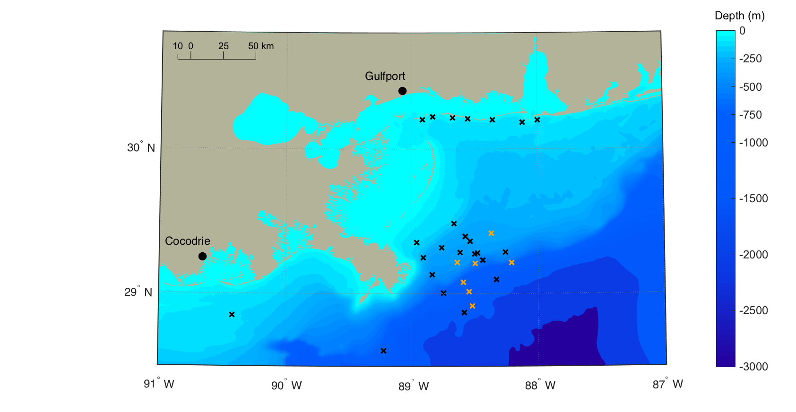
Scanfish/Shipboard lidar
Figure 4. Station locations. Orange stations denote the locations of the dye releases
During the Scanfish tows, the Scanfish will be deployed from the stern and towed at 4 knots. Coincident data will be collected from the ship-borne polarimetric and multi-wavelength lidars on the bow.

Stations
Stations are categorized into long (LS) and short(SS) depending on the data collected:
- Long Stations:
  - CTD/water samples
  - Bio-optical profiler
  - MVSM/LISST
  - Profiling lidar
  - Hyperpro
  - ASD
- Short Stations:
  - CTD/water samples
  - Bio-optical profiler
  - MVSM/LISST
  - ASD
Space permitting, the CTD, bio-optical profiler, MVSM/LISST, and profiling lidar will be deployed from the starboard A-frame. The Hyperpro will be deployed from the stern. Water samples will be collected and analyzed from the surface and at least one other depth at each station, with more samples possible depending on the subsurface profiles.

Dye releases
Under ideal conditions we will release dye a total of 5 times under different atmospheric conditions. Seven attempts have been scheduled in the cruise plan with the expectation that weather will prevent some. Under normal conditions, dyes will be released from the sprayer and subsurface diffusors attached to the vessel outrigger. When rough weather prevents the outrigger from being deployed, a surface-only release will occur from a backup sprayer attached to the stern A-frame. The key steps for the dye release are outlined below.
- Position vessel perpendicular to wind direction and away from production platforms and other obstacles
- Extend vessel outrigger and deploy depressor, CTDs, and hoses
- As slow as the vessel is able, transit perpendicular to the wind while releasing dyes from the sprayer and diffusers. Dye release will occur over a one-hour period
- When dye release is finished, retract outrigger, retrieve depressor, and ready Scanfish for deployment
- Turn vessel around, deploy Scanfish and turn on multi-wavelength lidar and high frequency ADCPs and pass back through the dye plume.

